

Submitted By:
Umair Umar CE-25-107
Assignment:
CA Lab No. 3
Submitted To:
Mehmood
For the fulfillment of,
Circuit Analysis Lab
Department of Computer Engineering
University of Engineering and Technology, Lahore

Circuit Analysis Lab 3
Lab Task 1:
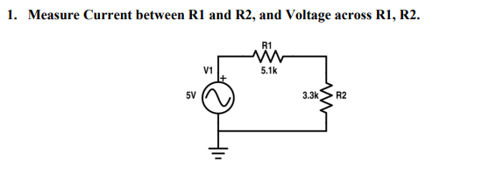
Theoretical Values
RMS Voltage = 5 ÷ √2 = 3.53V
Total Resistance = R1 + R2 = 5.1k + 3.3k = 8.4kΩ
Current I = V ÷ R = 3.54 ÷ 8400 = 0.421 mA
V R1 = [5.1k / 8.4k] × 3.54 = 2.14V
V R2 = [3.3k / 8.4k] × 3.54 = 1.39V
Verification: 2.14 + 1.39 = 3.53 ≈ 3.54V ✓

R1 Voltage | R2 Voltage | Current
2.14V | 1.39V | 0.421 mA

Practical Values
R1 Voltage | R2 Voltage | Current
2.14V | 1.39V | 0.421 mA

Lab Task 2:
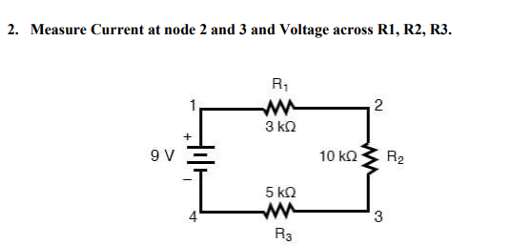
Theoretical Values
Total Resistance = R1 + R2 + R3 = 3k + 10k + 5k = 18kΩ
Current I = V ÷ R = 9 ÷ 18000 = 0.5 mA
V R1 = [3k / 18k] × 9 = 1.5V
V R2 = [10k / 18k] × 9 = 5V
V R3 = [5k / 18k] × 9 = 2.5V
Verification: 1.5 + 5 + 2.5 = 9V ✓

R1 Voltage | R2 Voltage | R3 Voltage | Current Node 2 | Current Node 3
1.5V | 5V | 2.5V | 0.5 mA | 0.5 mA

Practical Values
R1 Voltage | R2 Voltage | R3 Voltage | Current Node 2 | Current Node 3
1.5V | 5V | 2.5V | 0.5 mA | 0.5 mA

Post Lab Questions
1. Define energy.
Energy is the capacity to do work. In electrical circuits it is the ability to move charges through a conductor. Unit is Joules (J).
2. Define power.
Power is the rate at which energy is consumed or produced in a circuit. Formula: P = V × I. Unit is Watts (W).
3. What is charge?
Charge is the fundamental property of matter that causes it to experience electromagnetic force. Unit is Coulombs (C).
4. What is a circuit?
A circuit is a closed loop path through which electric current flows from a source through components and back to the source.
5. What is the role of a resistor in a series circuit?
A resistor limits and controls the flow of current in the circuit. In a series circuit it drops a portion of the total voltage proportional to its resistance value.
6. What is the voltage divider rule?
The voltage across a resistor in a series circuit is proportional to its resistance relative to total resistance. Formula: V R = [R / R total] × Vs
7. What are the features of a series circuit?
Current is the same throughout the circuit. Total resistance equals the sum of all resistors. Voltages across components add up to the source voltage. If one component fails the whole circuit breaks.
8. Differentiate between the internal circuit of voltmeter and ammeter.
A voltmeter has very high internal resistance and is connected in parallel across a component. An ammeter has very low internal resistance and is connected in series by breaking the circuit.
9. In which combination do we connect DMM to measure current and voltage?
For voltage measurement the DMM is connected in parallel across the component. For current measurement the DMM is connected in series by opening the circuit and inserting it in the gap.

